7 inch Muilt-Function Digital Alarm Calendar Speaker for Family Schedules with 16GB Memory
(Tasks&Rewards&Penalties / Photo&Video Album / Multi-Calendar Sync / Audio Center / Sleep&Wake Routine / Weather Station) Smart Alarm Calendar Speaker Function

Model | Product Features | Price USD
Model | Product Features | Sample | 1K-3K
CT070M-B01 | Dual-WiFi + BT5.4 + AI Voice Interaction+Light Sensor + Family Calendar  & Event Management + Tasks, Rewards & Penalties + Multi-Calendar Sync + Holiday  & Sports Subscriptions + Weather Station + Photo & Video Album + Audio Center +  Sleep & Wake Routine + Sunrise Light Alarm + Local Offline Alarm + Pomodoro &  Countdown Timer + Hourly Chime + Auto Brightness & Sleep Mode+ Ambient Light
Model No: CT070M-B01 IPS Screen 1024*600 (16:9)

Remark: FOB Shenzhen price, the delivery time is about 25-30 days for 1-5K order
Private Tooling ：Plastic Design
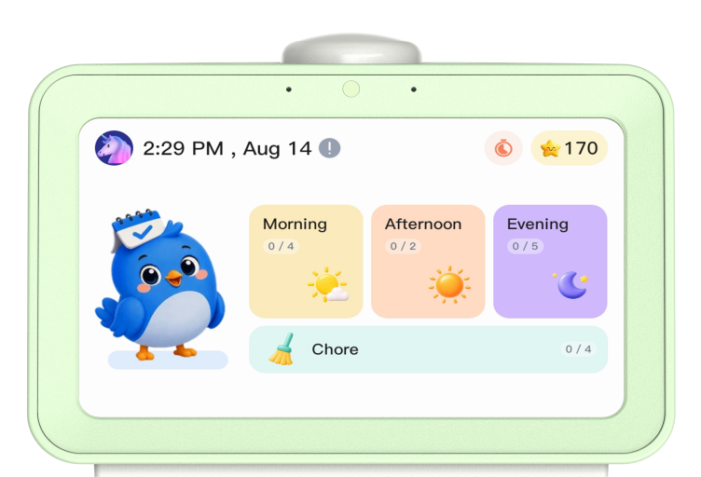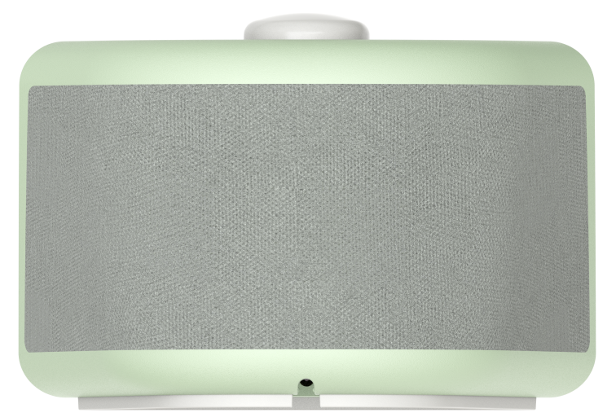
CT070M-B01

Selling Points：
- Sunrise Light Alarm & Smart Timekeeping – Gentle wake-up with sunrise simulation, offline local time support, and multi-device sync across your home.
- Multilevel Ambient Night Light – Adjustable bedside and desk lighting for any scene.
- Smart Family Calendar – Manage schedules anytime via the eCalendar App. Week/Month/Day views, filter by member.
- Seamless Calendar Sync – One-tap sync with Google, Outlook, iCloud, Cozi & any ICS/URL. Subscribe to holidays and sports.
- Daily Routine & Task Management – Morning, Afternoon, Evening & Chore modules with custom timers, repeats, due times, and overdue penalties.
- Star Rewards & Family Motivation – Earn stars, redeem rewards, face penalties. Full history log. Competitive tasks engage everyone.
- Sleep & Wake Routine – Cue to Sleep with custom audio. Sleep Steps, Snooze, and Sunrise Mode for gentle mornings.
- Family Photo & Video Album – Upload from app, preview on device. Folder management, favorites, copy & transfer.
- Audio Center & Sleep Sounds – Bedtime playback with seamless app-to-device switching.
- Member & User Management – Custom avatars & color labels. Invite by email, device name, or link. Full permission control.
- AI Voice Interaction – Simple voice commands for hands-free control.
- Space-Saving Cute Stand Design – A stylish home decoration that fits any desk or bedside.

Features:
- 7 inch WiFi Cloud Smart Alarm Calendar Speaker with Newest Unique Design
- Support Alarm Clock &Cloud WIFI & 16GB built-in memory
- High Resolution: 1024*600(16:9) Pixels
- IPS Panel with Touch Panel
- Support Weather Station Function
- Support Android / iOS

Specification:
- Display: 7 inch Incell IPS Panel (16:9) Touch Screen
- Resolution : 1024*600 Pixels
- Connect Internet: Dual WiFi (2.4G+5G)
- Built-in Memory: 16GB
- Interface: Type-C & DC
- Full Function: Dual-WiFi + BT5.4 + AI Voice Interaction+Light Sensor + Family Calendar & Event Management + Tasks, Rewards & Penalties + Multi-Calendar Sync + Holiday & Sports Subscriptions + Weather Station + Photo & Video Album + Audio Center + Sleep & Wake Routine + Sunrise Light Alarm + Local Offline Alarm + Pomodoro & Countdown Timer + Hourly Chime + Auto Brightness & Sleep Mode+ Ambient Light
- Special Design: Cute Design + Ambient Night Light
- Member Plus: Email Import
- Software: In-house R&D Software eCalendar APP Supported by World Famous Cloud System

Description:
- Smart Family Calendar & Event Management
①Multi-Calendar Sync: Sync with Google, Outlook, iCloud, Cozi and ICS/URL calendars for family schedules, holidays and event management.
②Family Calendar Management: View schedules by week/month/day, filter by family members, and manage daily events easily.
- Smart Alarms & Task Management
①Sunrise Light Alarm: Simulate natural sunrise with gradual light changes and gentle alarms for a comfortable wake-up experience.
②Task & Reward Management: Create tasks, set reminders, track completion, earn stars and redeem rewards with family motivation.
- Multi-functional Clock & Timer
① Clock & Time Management: Support local offline alarm, timekeeping clock and multi-device synchronization.
② Pomodoro & Countdown Timer: Customize focus sessions, countdown reminders and hourly chime for better time management.
- Weather & Audio Center
① Real-time Weather Information: Display local weather conditions with automatic location or manual city selection.
② Audio Center & Sleep Sounds: Support bedtime audio playback with white noise and natural sounds for relaxation and sleep.
- Ambient Light & Smart Sleep Mode
① Multi-level Ambient Night Light: Adjustable brightness and ambient lighting effects for bedside and desk scenarios.
② Smart Sleep Mode: Automatically adjust brightness, volume and sleep settings according to customized schedules.
- Photo & Video Album Management:
① Family Photo & Video Album: Upload, preview and manage photos and videos through the eCalendar App.
② Cloud Album Sharing: Support shared folders and family media management.
- Smart Device Connection & Mobile App Control
① Quick Device Connection: Support device code or QR code pairing for easy setup.
② Remote Device Management: Control watch faces, sounds, brightness and sleep modes through the mobile app.
- Smart Voice Interaction & User Management
① AI Voice Interaction: Support simple voice commands for convenient hands-free operation.
② User Profile Management: Manage user information and multiple family members.

Accessories: User Manual, Adapter

Standard Certification: CE /FCC/ROHS

Warranty: One year

Export Carton:(TBD)
1.20 units per carton
2.Giftbox Size: L340*W197*H31MM
3.Carton Size: L408*W358*H367MM
4. Carton Weight: NW: KG, GW: KG
5.20" FCL/40"FCL/40"HQ: 500/1080/1280 Cartons
20" FCL/40"FCL/40"HQ: 10000/21600/25600 PCS

JOYHONG will provide the information as correct as possible. Product photos on this website may vary from the real products. Products information may vary from the products manual available in the market. Please use the products subjected to the specific information on the user manual. For details, please contact the related persons.

