15.6 inch Full Function Digital Calendar for Family Schedules with 32GB Memory
(Event Management /Task/Rewards+Penalty /Enhanced To-Do Lists /Photo Display /Sync & Profies /Multi-view Meal Plan /Weather Station/Sleep Mode/Reminders/AI Function/Dashboard/Timer)

Model | Product Features | Price USD
Model | Product Features | Sample | 1K-3K
JT156M-M01 | Event Management+Tasks&Rewards+Penalty+Enhanced To-do Lists+Photo Display+Sync Calendars+Profiles(Support avatar function)+Weather Station+Cloud Album+ Email Import+Full HD Movie+Sleep Mode+Reminders+Light Sensor+Dual-WiFi+AI Function+Timer+Multi-view Meal Plan+iOS Wedget Dashboard+One-tap Holiday Subscriptions+Color-Coded Task Cards
Model No: JT156M-M01 IPS Screen 1920*1080 Pixels (16:9)

Remark: FOB Shenzhen price, the delivery time is about 25-30 days for 1-5K order
Private Tooling ：Plastic Front Design

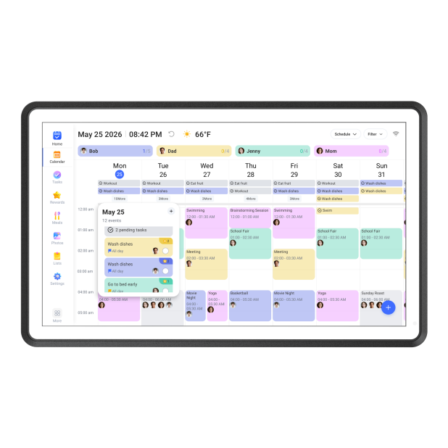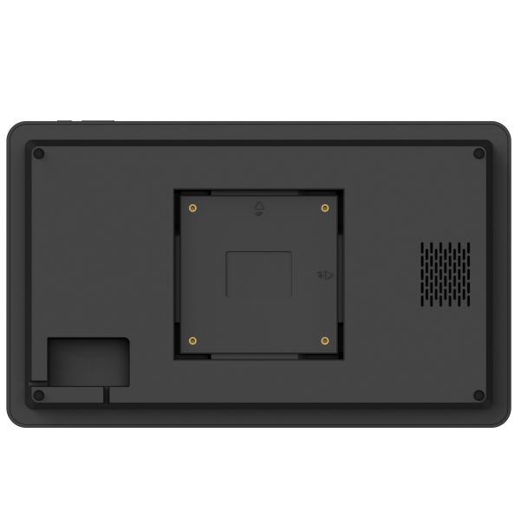

JT156M-M01
Selling Points：
- Selectable Reminders for All Events
- Intuitive Touchscreen Interface for Easy Operation
- Slim Border Design for Home Decoration
- Auto-Sync with Google, Apple, Outlook, Cozi and TeamSnap Calendars
- Multi-Device Sync Under One Account to Keep Every Room in Sync
- GDPR Certification Ensures Strong Data Protection, Builds User Trust, and Provides a Competitive Edge
- Personal AI assistant helps you enjoy a smarter way to operate eCalendar
- Smart Pomodoro Timer combines countdown and stopwatch modes, putting every focus session's rhythm right in your hands.
- Advanced Meal Planner with Daily and Weekly Planning Views for Easy Meal Scheduling
- All-in-One Dashboard That Hosts Your Schedule, Photos, Lists, and More – No Need to Switch Between Functions
- Customizable Members with Personalized Color Labels and a Library of Cartoon Avatars
- One-Tap Holiday Subscription to Official Public Holidays in Major Countries
- Upgraded Sleep Mode with Customizable Schedules by Day of Week and Support for Multiple Time Slots
- Improved Task Switches with Clearer Display of Completed and Overdue Tasks
- Enhanced To-Do Lists with Member Assignment, Due Time Setting, and Efficient Task Management

Features:
- 15.6 inch Android Wifi Cloud Digital Calendar with Newest Unique Design
- Support Full HD Movie & Cloud WIFI & 32GB built-in memory
- High Resolution:1920*1080 Pixels
- IPS Screen New IPS Touch Panel
- Support Weather Station Function
- Support Android system
- Dual WiFi (2.4G & 5G)
- Supported Image Formats: JPEG, BMP, GIF, PNG
- Video Formats: MP4 (Only)

Specification & Features:
- Display: 15.6 inch IPS Panel (16:9) Touch Screen
- Resolution: 1920*1080 Pixels
- Connectivity:Dual WiFi (2.4G+5G)
- Built-in Memory: 32G
- Interface: DC IN&Type-C
- Full Function: Event Management+Tasks&Rewards+Penalty+Enhanced To-do Lists+Photo Display+Sync Calendars+Profiles(Support avatar function)+Weather Station+Cloud Album+ Email Import+Full HD Movie+Sleep Mode+Reminders+Light Sensor+Dual-WiFi+AI Function+Timer+Multi-view Meal Plan+iOS Wedget Dashboard+One-tap Holiday Subscriptions+Color-Coded Task Cards
- Special Design: Round Design+Multi-Position Bracket for Wall-Mountable(Optional) +Multi-Position Desk Stand
- Member Plus: Email Import+AI Function
- Software: In-house R&D Software eCalendar APP Supported by World Famous Cloud System

Description:
- Auto-sync Google(Dual Ways), Apple(Dual Ways), Outlook(Dual Ways), Cozi and Teamsnap Calendar to your family calendar, convenient for your schedule management
- Support switch seamlessly between day, week, month and plan views to meet different planning needs and preferences
- A task reward and penalty system encourages healthy habits and autonomy through interactive family checklists, with late tasks earning no reward but penalties.
- Enhanced to-do lists with assignment, due dates, and custom organization for tasks, to-dos & groceries.
- By combining advanced data analysis with real-time precise weather forecasting, prepare for the exact time and location of events
- Multi-view Meal Plan offers flexible daily and weekly views for effortless meal scheduling.
- Email can import any email, spreadsheet, or PDF with dates and seamlessly convert them into calendar events.（Plus Member Support）
- Support to share photos&videos via app to calendar to use as digital photo frame, storage pretty moments on your album, and screensaver can be set to play a specified photo album
- Digital Calendar for All-in-One Family Schedule & Tasks
- Support to Use a mobile app to remote manage and access schedules on eCalendar anytime, anywhere.
- Intuitive Touchscreen Interface for Easy Operate
- Simplicity, fashion, Elegant Flat design,desk stand home decoration.
- Applicable Scenarios：Home Organization/Office Productivity/School & Classroom/Business & Retail/Event Planning/Fitness & Wellness/Kitchen Planning/Elderly Care/Smart Home Integration/Gift Choice
- Applicable Scenario Products: ①Enterprise Productivity: Digital calendar for conference rooms②Education: Interactive school calendar display ③Healthcare: HIPAA-compliant medical scheduler④Smart Home: Smart mirror with integrated calendar ⑤Public Sector: Digital public event calendar
- Target Users：for Kids, Students, Elderly, Parents, Office Managers, School Administrators, Healthcare IT Staff, Smart Home Enthusiasts, Government Procurement

Accessories: Use Manual , Adapter, Bracket

Unit Size:400.22X249.62X18.8MM

Unit Weight:1.54Kg

Standard Certification: CE /FCC/ROHS

Warranty: One year

Export Carton:
1.5 units per carton
2.Giftbox Size: 523x292x60 MM
3.Carton Size:539x320x317 MM
4. Carton Weight: NW: 13.57 KG, GW: 14.41KG
5.20" FCL/40"FCL/40"HQ: 490/1078/1232 Cartons
20" FCL/40"FCL/40"HQ: 2450/5390/6160 PCS

JOYHONG will provide the information as correct as possible. Product photos on this website may vary from the real products. Products information may vary from the products manual available in the market. Please use the products subjected to the specific information on the user manual. For details, please contact the related persons.

